**Facing issue with SSH when we are trying to login into**

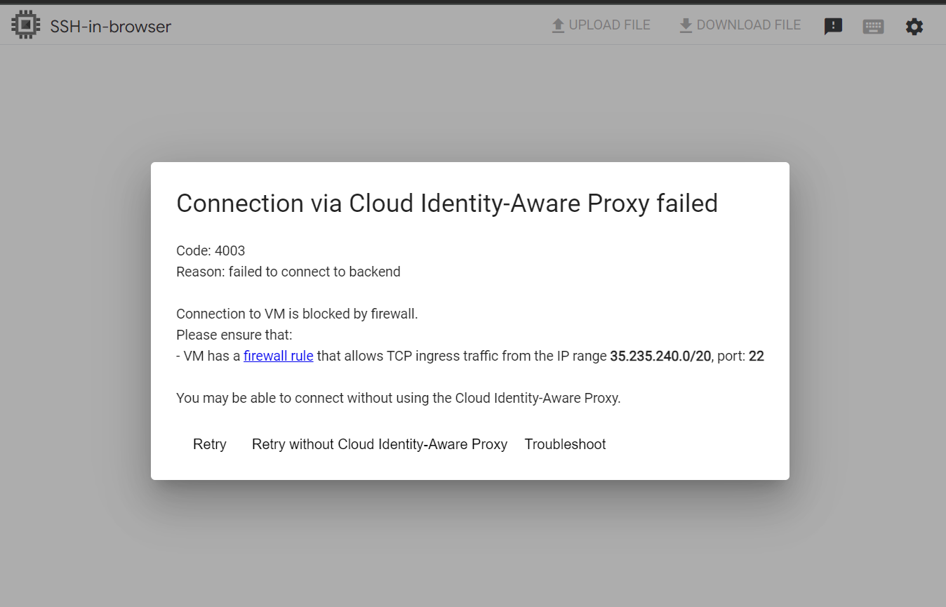

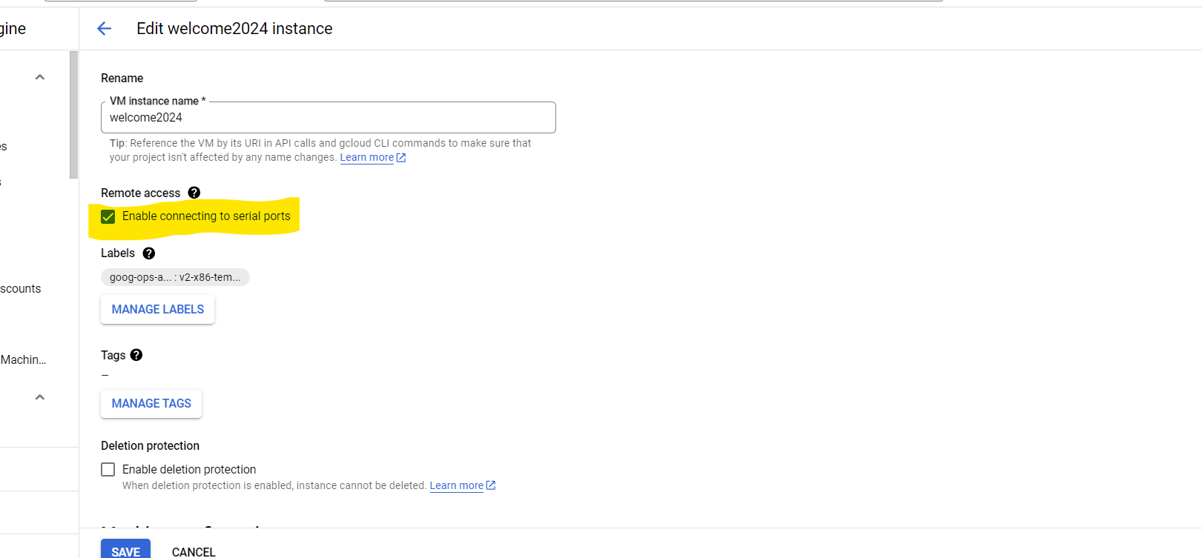

We will insert this info into Metadata

#!/bin/bash  
useradd rahul  
echo rahul:madan | chpasswd  
usermod -aG google-sudoers Rahul

After that we will again able to disable remote access

Enable connecting to serial console

<https://cloud.google.com/compute/docs/troubleshooting/troubleshooting-using-serial-console#console>